INTELLIGENT MULTI-INDICATOR VISUAL SURVEILLANCE SYSTEM

1. Introduction & Problem Context
Surveillance systems deployed in semi-controlled environments such as lecture halls, hallways, and restricted access areas are traditionally passive and reactive. Human operators must continuously monitor video streams, leading to fatigue, delayed responses, and inconsistent enforcement of security protocols.
While recent advances in computer vision have significantly improved object detection and low-light enhancement capabilities (Ghari et al., 2024; Li et al., 2021), most existing systems focus narrowly on either detection accuracy or single-indicator anomaly detection. Real-world surveillance environments, however, demand systems that can reason about multiple behavioral indicators simultaneously while operating under realistic constraints.
Academic and institutional environments present unique challenges:
- Low illumination in corridors and outdoor areas during evening hours
- Motion blur from fast-moving subjects
- Occlusion in crowded scenarios
- Environmental noise including vehicles, weather conditions, and non-human movement
- Variable crowding patterns across different times of day
Additionally, practical deployment constraints require surveillance systems to:
- Operate on edge hardware with limited computational resources
- Preserve privacy by avoiding identity-based recognition
- Maintain power efficiency through intelligent processing strategies
- Function reliably without continuous internet connectivity
This project proposes a modular, edge-deployable intelligent surveillance system capable of detecting multiple behavioral anomaly indicators simultaneously while operating under realistic environmental and computational constraints. The system emphasizes privacy preservation, power awareness, and practical deployability in semi-controlled academic environments.

2. Project Objectives

2.1 Primary Objective
Design and implement a modular, privacy-preserving, edge-optimized visual surveillance system capable of detecting multiple behavioral anomaly indicators in semi-controlled environments.

2.2 Sub-Objectives
- Develop robust person detection under low-light conditions
Inspired by recent advances in low-light detection (Ghari et al., 2024; Li et al., 2021).
- Integrate lightweight multi-object tracking to enable temporal behavioral reasoning across frames.
- Implement modular behavioral indicators:
  - Tailgating detection
  - Lingering detection
  - Abnormal motion pattern detection
  - Crowd density monitoring

- Enable post-deployment configurability through feature activation/deactivation of specific indicator modules.
- Implement event-triggered power-aware operation to reduce energy consumption during periods of no activity.
- Optimize system for edge deployment using model compression techniques including quantization and pruning (Gholami et al., 2021; Batzner et al., 2023).
- Conduct hybrid validation using both public datasets and staged real-world scenarios to ensure practical robustness.

3. System Requirements

3.1 Functional Requirements
- Real-time person detection with high accuracy across varying lighting conditions
- Multi-object tracking capability across consecutive frames
- Temporal feature extraction including dwell time, trajectory analysis, and inter-person distance measurement
- Modular anomaly indicator processing with independent indicator modules
- Event-triggered alert generation based on configurable thresholds
- Feature activation/deactivation via runtime configuration without redeployment
- Power-aware idle mode that activates when no activity is detected
- Conditional evidence escalation for critical events requiring enriched data storage or transmission

3.2 Non-Functional Requirements
- Performance: Operate at near real-time frame rates (≥ target FPS) on edge-class hardware
- Robustness: Maintain detection reliability under low-light conditions and environmental variations
- Privacy: Operate without facial recognition or identity-based tracking
- Efficiency: Minimize computational footprint and power consumption
- Reliability: Maintain low false positive rates in realistic deployment scenarios
- Scalability: Support deployment across both indoor and semi-outdoor environments
- Maintainability: Enable configuration changes without system redeployment

4. Gap Analysis
A comprehensive review of existing literature reveals several critical limitations in current surveillance systems:
Literature Area | Key Limitation
Low-light detection surveys  (Ghari et al., 2024; Li et al., 2021) | Focus primarily on detection accuracy metrics without addressing multi-indicator behavioral reasoning
Edge anomaly systems  (Ali et al., 2024) | Often implement single-indicator detection or lack modular design for flexible deployment
Face detection in degraded conditions  (Zhou et al., 2018) | Raise significant privacy concerns and demonstrate poor robustness under low-light conditions
Pose/skeleton-based behavioral systems | Require computationally expensive processing unsuitable for edge devices
Crowd analysis literature | Rarely integrated into modular real-time systems with configurable indicators

Identified Research Gap
There is limited research on modular, multi-indicator behavioral anomaly detection systems designed specifically for edge deployment in semi-controlled academic environments with power-aware operation.
This gap is particularly significant because:
- Academic environments require privacy-preserving solutions
- Resource constraints demand edge-optimized architectures
- Varied scenarios necessitate configurable, modular indicator systems
- Practical deployment requires power-efficient operation
This project directly addresses this gap by combining multi-indicator reasoning, edge optimization, privacy preservation, and power-aware design into a unified, practical system.

5. Proposed System Architecture

5.1 High-Level Process Flow
The system follows a structured pipeline from camera input to alert generation:
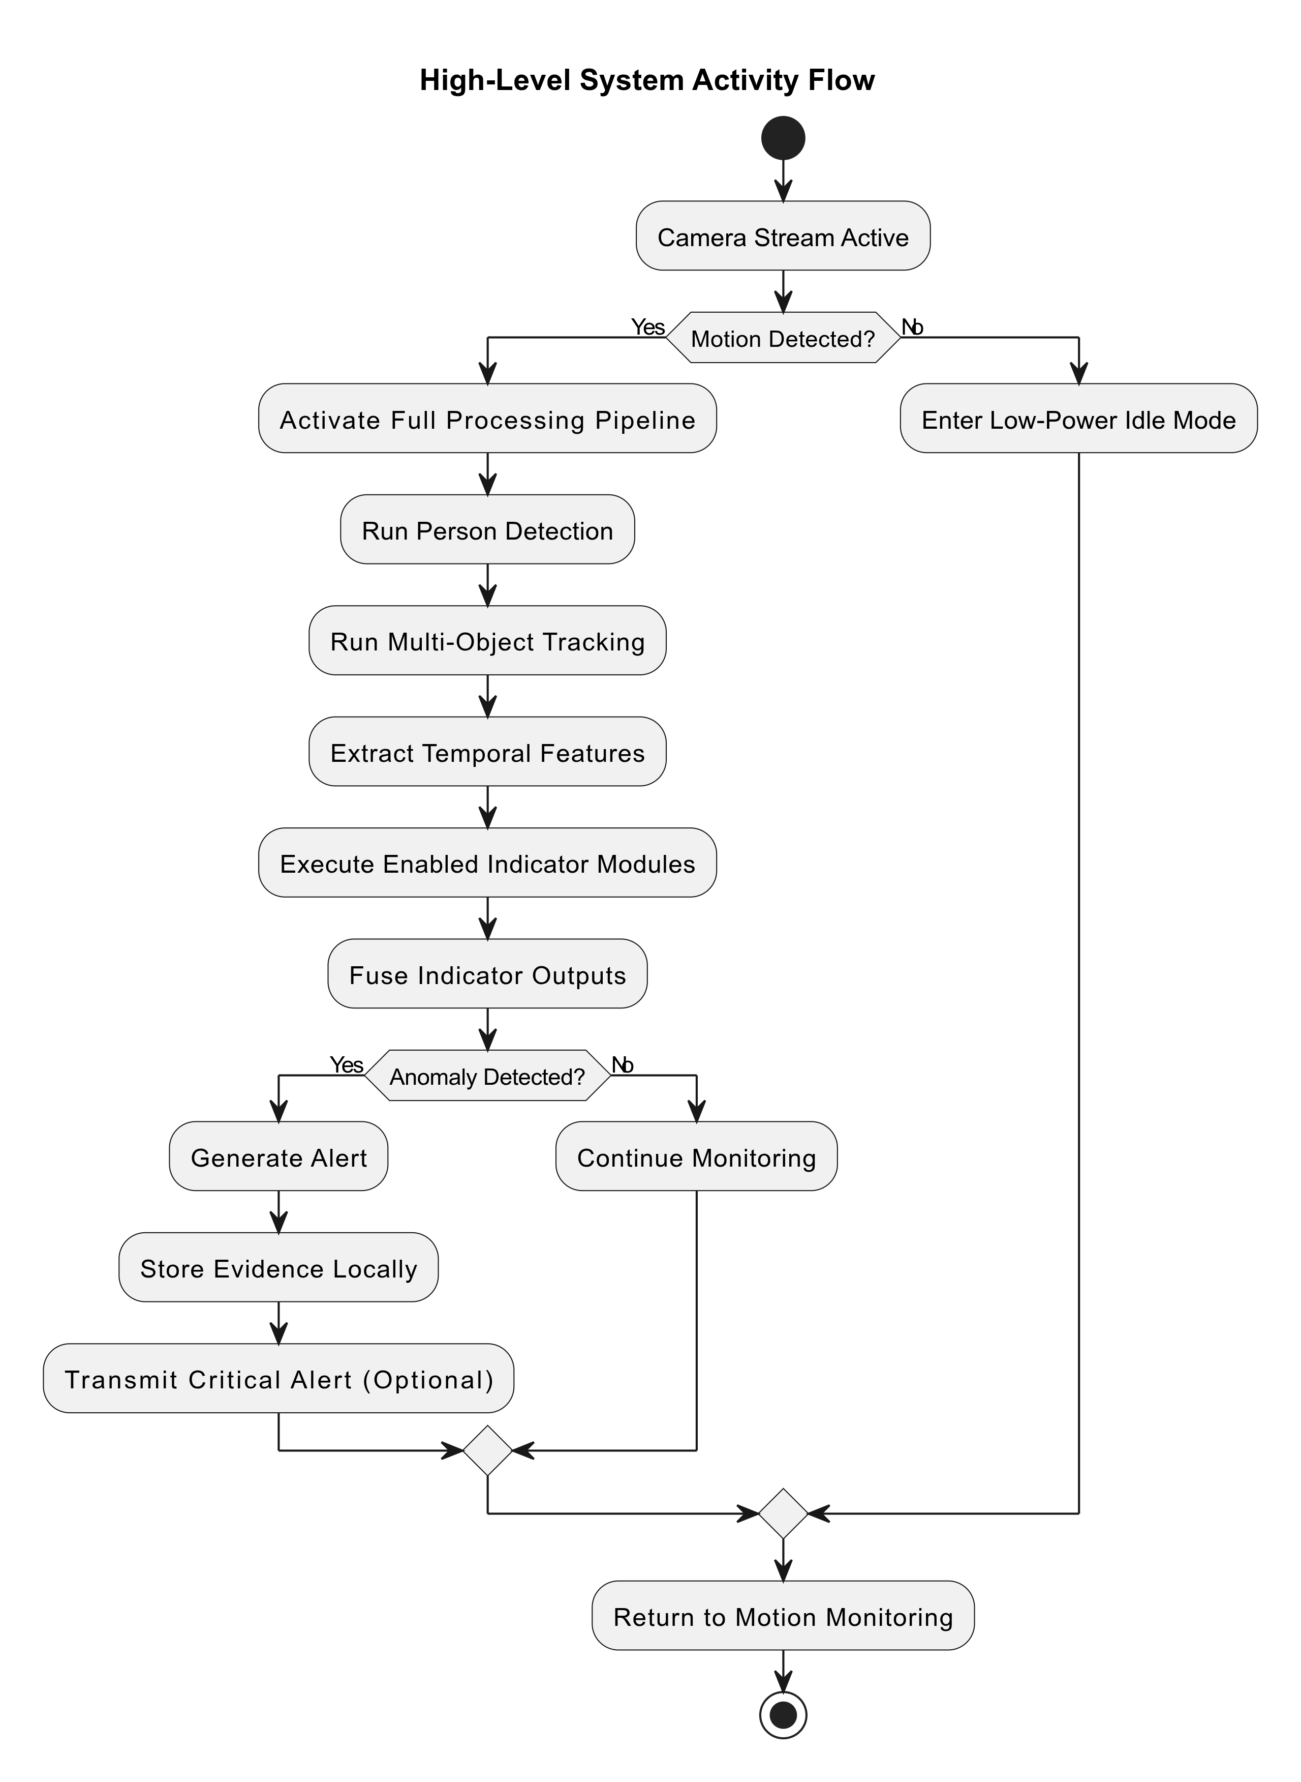
This architecture is inspired by detection robustness studies (Ghari et al., 2024) and edge optimization principles (Gholami et al., 2021).

5.2 Modular Component Interaction Diagram
The system is designed with clear separation of concerns and modular independence:
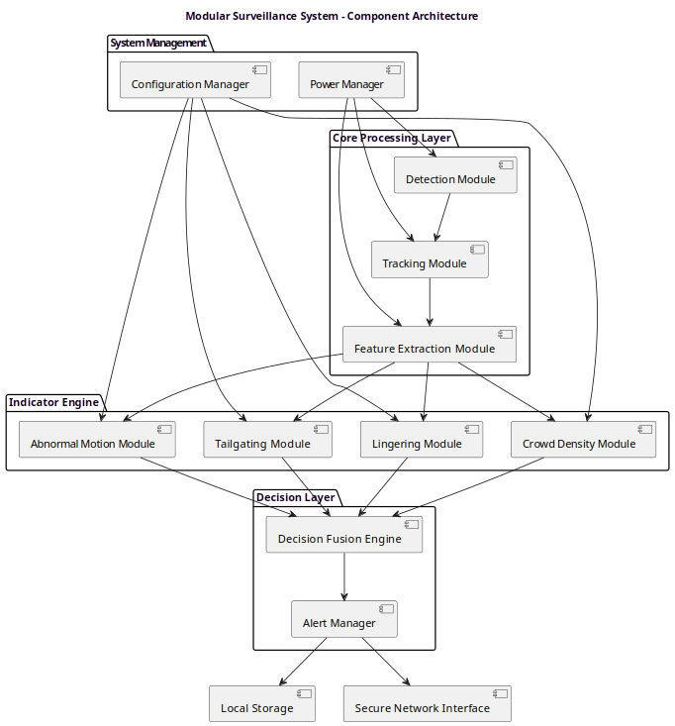

Key Architectural Benefits:
- Plug-and-play indicator modules enable easy addition or removal of detection capabilities
- Configuration manager allows runtime feature activation without redeployment
- Separation of concerns facilitates independent testing and optimization of each component
- Power manager operates independently to control system-wide power states

5.3 Power-Aware Event-Triggered Design
To minimize power consumption during periods of inactivity, the system implements a two-tier detection strategy:
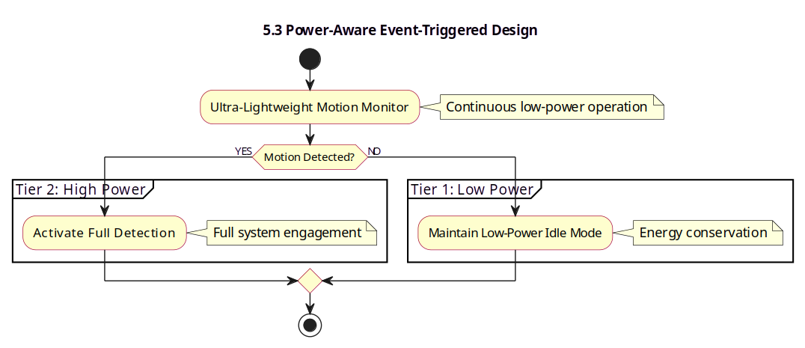
Design Rationale:
- An ultra-light motion detector runs continuously with minimal power draw
- Full detection pipeline activates only when motion is detected
- System reverts to idle mode after configurable period of inactivity
- This approach significantly reduces average power consumption compared to continuous processing
This design is inspired by edge computing efficiency principles (Ali et al., 2024) and lightweight model optimization strategies (Gholami et al., 2021).

5.4 Deployment Diagram (Edge Architecture)
The system is designed for local edge processing with minimal network dependency:
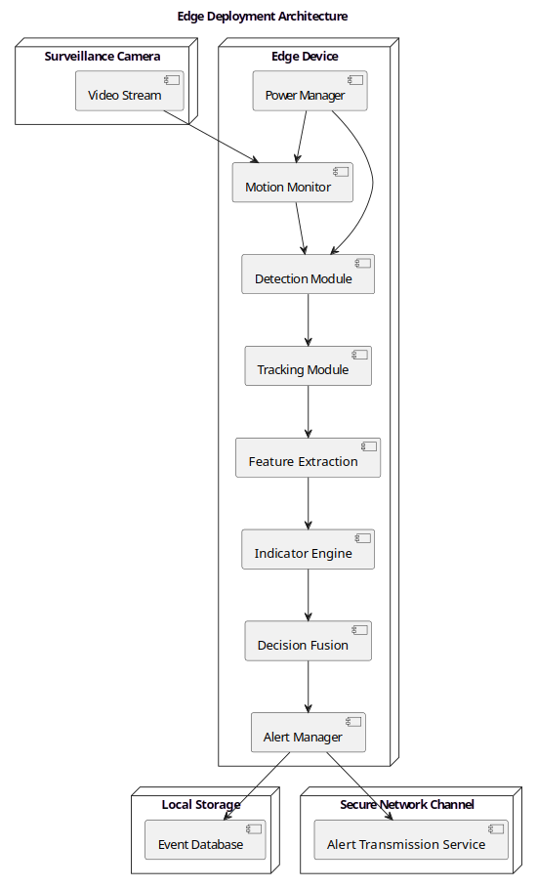

Privacy and Efficiency Benefits:
- All inference performed locally on edge device
- No continuous video streaming to cloud or central server
- Network transmission occurs only during critical events requiring human attention
- Local storage maintains audit trail without cloud dependency
- Conditional evidence escalation transmits enriched data only when necessary

6. Dataset & Robustness Strategy

6.1 Hybrid Dataset Strategy
The system will be trained and validated using a combination of public datasets and staged real-world scenarios:

Public Datasets
- COCO / CrowdHuman: Base person detection capability
- LLIV-Phone (Li et al., 2021): Low-light robustness
- ExDark: Additional low-light variation and degraded condition handling

Staged Real-World Data Collection
- Tailgating scenarios: Controlled simulations with varying temporal gaps
- Lingering behavior: Subjects dwelling in areas for varying durations
- Controlled crowd buildup: Gradual density increases to test thresholds
- Abnormal movement patterns: Unusual trajectories and motion characteristics

6.2 Systematic Data Augmentation
To address the generalization gaps identified by Zhou et al. (2018) regarding real-world deployment challenges, the following augmentation strategies will be applied:
- Illumination scaling: Simulating various lighting conditions from bright daylight to low-light scenarios
- Motion blur simulation: Replicating fast-moving subjects
- Noise injection: Adding sensor noise and environmental artifacts
- Partial occlusion: Simulating crowding and object obstruction
- Weather overlays: Rain, fog, and other atmospheric conditions (for semi-outdoor deployments)
Strategic Principle:
Robustness will be primarily achieved through training diversity rather than heavy runtime enhancement pipelines, ensuring computational efficiency on edge devices.

7. Methodology
The project will follow a phased development approach with clear validation milestones at each stage:

Phase 1 – Baseline Prototyping (Laptop-Based Development)
Objectives:
- Establish baseline detection and tracking capability
- Profile computational requirements
- Validate approach on realistic data
Activities:
- Train lightweight person detector (YOLOv8n or equivalent)
- Integrate multi-object tracking module
- Measure FPS and latency on development hardware
- Validate on:
  - Public datasets (COCO, CrowdHuman, ExDark)
  - Real recorded corridor/hallway scenes
Critical Note: Real-world validation begins during prototyping phase to identify practical challenges early.

Phase 2 – Indicator Module Development
Each behavioral indicator will be developed as an independent, testable module:
Lingering Detection:
- Dwell time threshold calculation
- Spatial zone definition
- Temporal window configuration
Tailgating Detection:
- Temporal gap measurement between consecutive entries
- Spatial proximity logic for co-movement detection
- Entry event correlation

Abnormal Motion Detection:
- Trajectory deviation analysis
- Motion pattern baseline establishment
- Anomaly scoring mechanism
Crowd Density Monitoring:
- Spatial person count calculation
- Density threshold configuration
- Temporal density change detection

Phase 3 – Multi-Indicator Fusion & Tuning
Objectives:
- Combine multiple indicator outputs into unified decision
- Optimize thresholds to minimize false positives
- Validate fusion logic on realistic scenarios
Activities:
- Implement weighted scoring mechanism for multi-indicator fusion
- Threshold optimization through systematic testing
- False positive analysis across different scenarios
- Confusion matrix generation for each indicator

Phase 4 – Edge Optimization
Objectives:
- Compress models for edge deployment
- Achieve target FPS on edge hardware
- Validate accuracy retention after optimization
Activities:
- Quantization: Convert models to INT8 precision where feasible
- Model pruning: Remove redundant parameters
- TFLite conversion: Prepare models for edge deployment
- Benchmarking: Profile FPS, latency, and memory usage on selected edge hardware
This phase aligns with optimization methodologies described in Gholami et al. (2021) and Batzner et al. (2023).

Phase 5 – Edge Deployment & Field Testing
Deployment Scenarios:
- Lecture hall entrance: Tailgating and crowd monitoring
- Hallway corridor: Lingering and abnormal motion detection
- Restricted area boundary: Unauthorized presence detection
Evaluation Metrics:
- Performance: Frames per second (FPS) on edge hardware
- Accuracy: Detection precision and recall across indicators
- Efficiency: Average power consumption in idle vs. active modes
- Reliability: False alarm rate and missed detection rate
- Robustness: Performance across different lighting conditions and crowding levels
Field Testing Protocol:
- Deploy system in controlled test environment
- Run continuous monitoring for defined evaluation period
- Log all detections and alerts with ground truth annotation
- Analyze performance across different times of day and environmental conditions

8. Expected Contributions
This project will deliver the following contributions:

8.1 Technical Contributions
- Modular Multi-Indicator Anomaly Detection Framework
A flexible architecture supporting independent development, testing, and deployment of behavioral indicators.
- Power-Aware Edge Surveillance Architecture
An event-triggered processing design that significantly reduces power consumption compared to continuous processing approaches.
- Hybrid Dataset Robustness Strategy
A systematic approach combining public datasets, staged data collection, and comprehensive augmentation for real-world robustness.
- Configurable Indicator Activation Mechanism
A runtime configuration system enabling post-deployment feature activation/deactivation without system redeployment.

8.2 Practical Contributions
- Validated Edge Deployment
Practical validation of multi-indicator surveillance in semi-controlled academic environments with measured performance metrics.
- Privacy-Preserving Design
A working system demonstrating effective behavioral anomaly detection without identity-based recognition.
- Realistic Performance Benchmarks
Documented performance characteristics under real-world conditions including low-light scenarios and varying crowd densities.

9. Conclusion
This project addresses a critical gap in intelligent surveillance systems by combining multi-indicator behavioral reasoning with practical deployment constraints. The proposed modular architecture enables flexible configuration, the power-aware design ensures efficient operation, and the privacy-preserving approach aligns with institutional requirements.
By grounding the system in realistic environmental conditions and validating through both public datasets and staged real-world scenarios, this project will deliver a practical, deployable solution for semi-controlled academic environments.
The phased methodology ensures systematic validation at each stage, while the emphasis on edge optimization and power awareness makes the system practical for real-world deployment.

References
Ali, M., Goyal, L., Sharma, C. M., & Kumar, S. (2024). Edge-computing-enabled abnormal activity recognition for visual surveillance. Electronics, 13(2), 251. https://doi.org/10.3390/electronics13020251
Batzner, K., Heckler, L., & König, R. (2023). EfficientAD: Accurate visual anomaly detection at millisecond-level latencies. Proceedings of the IEEE/CVF Conference on Computer Vision and Pattern Recognition (CVPR), 12821–12830.
Cheng, Y., Wang, D., Zhou, P., & Zhang, T. (2018). A survey of model compression and acceleration for deep neural networks. IEEE Signal Processing Magazine, 35(1), 126–136.
Ghari, B., Tourani, A., Shahbahrami, A., & Gaydadjiev, G. (2024). Pedestrian detection in low-light conditions: A comprehensive survey. IEEE Access, 12, 5835–5857.
Gholami, A., Kim, S., Dong, Z., Yao, Z., Mahoney, M. W., & Keutzer, K. (2021). A survey of quantization methods for efficient neural network inference. ACM Computing Surveys.
Li, C., Guo, C., Han, L. H., Jiang, J., Cheng, M. M., Gu, J., & Loy, C. C. (2021). Low-light image and video enhancement using deep learning: A survey. IEEE Transactions on Pattern Analysis and Machine Intelligence (TPAMI), 44(12), 9396–9416.
Zhou, Y., Liu, D., & Huang, T. (2018). Survey of face detection on low-quality images. IEEE Access, 6, 18471–18487.

